PRO MAXTM PROPELLER
OUTB O ARD PERF ORMANCE B OO S TER

THIS STAINLESS STEEL PROP — DESIGNED FOR high-performance OptiMax® Pro XS and 300XS, and Verado® Pro FourStroke — features Mercury Racing® Pro E.T.® drag race blades combined with a custom through-hub exhaust tube. This unique combination provides a 33 percent faster hole shot than the Pro E.T. and top-end speeds up to three mph faster.
It is ideal for use on bass, flats, cat flats, high-performance sport boats, and race boats.

KEY FEATURES
- Mercury exclusive X7® Alloy for unmatched strength and durability
- Parabolic blade rake for enhanced bow lift
- Efficient design provides an on-plane performance at 3500 RPM
- Reduced prop slip in high-speed turns
- Rated for 115-300 HP
- Right-hand rotation
- 14.50" diameter
- Available in Pro Finish and Lab Finish
  - Pro Finish: 1" pitch increments (23"-32")
  - Lab Finish: 2" pitch increments (24"-32")

PRO FINISH
PITCH DIAMETER ROTATION
23" 14.50" RH
24" 14.50" RH
25" 14.50" RH
26" 14.50" RH
27" 14.50" RH
28" 14.50" RH
29" 14.50" RH
30" 14.50" RH
31" 14.50" RH
32" 14.50" RH

LAB FINISH
PITCH DIAMETER ROTATION
24" 14.50" RH
26" 14.50" RH
28" 14.50" RH
30" 14.50" RH
32" 14.50" RH

Reynolds Racing and Marine
1019 South Roane Street
Harriman, TN 37748
865-882-9623 fax 865-882-6010

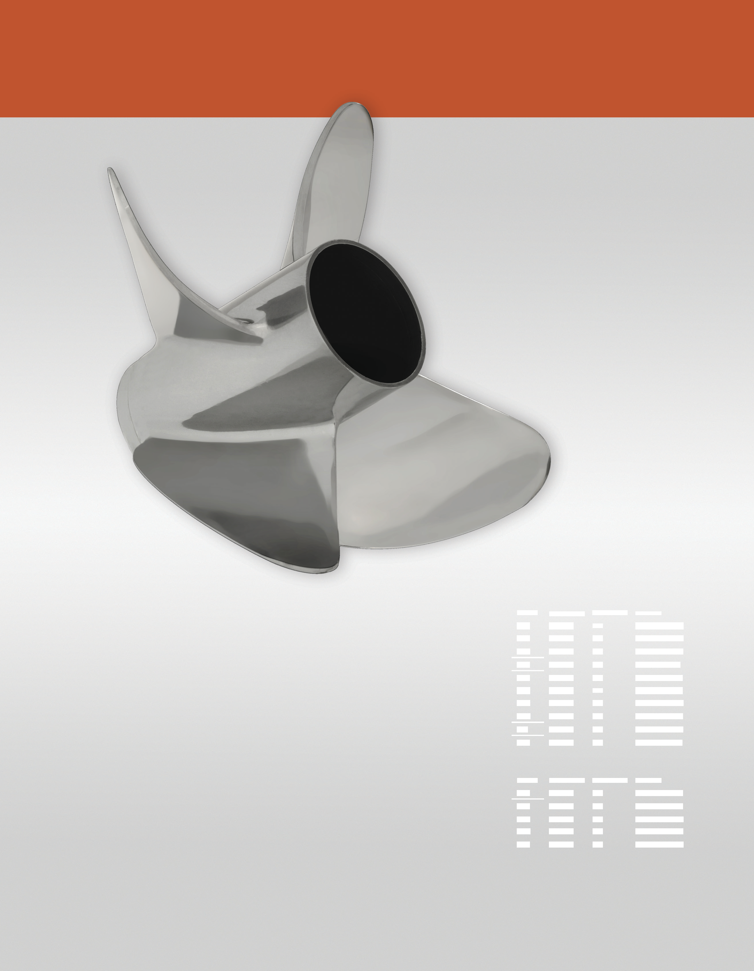
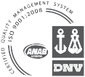
.

MERC UR YR A CING . C OM

